Dorothy Simmons wins Marjorie Barnard 2015 Short Story Award

As reported in the December issue of the Writers Voice:
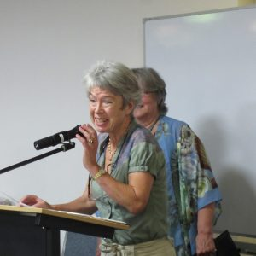
Dorothy Simmons
Irish-born Dorothy Simmons, from Albury, was the well-deserved winner of the Marjorie Barnard 2015 Short Story Award, her short story being judged the best from 75 entries.
The winning entry, titled ‘Count Down’, was read by the competition judge, Pippa Kay, who said she was immediately grabbed by the first sentence of Dorothy’s dramatic story. Winning this award follows hot on the heels of the launch of Dorothy’s book, Living like a Kelly.
Congratulations, Dorothy!
The judges report can be viewed via this link:
Judges Report for Marjorie Barnard Award 2015.

